Nicky Randles – B00058026

Network Distributed Systems

Assessment 2

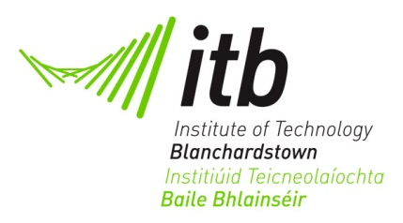

Project aims

The main objective of this project is to create a remote communication chat group system using the Java RMI. Multiply users must be able to join the server and chat with each other at once. Each user must be supplied with their own graphical user interface which allows them to view messages from other users and send messages to other users.

Wireframing

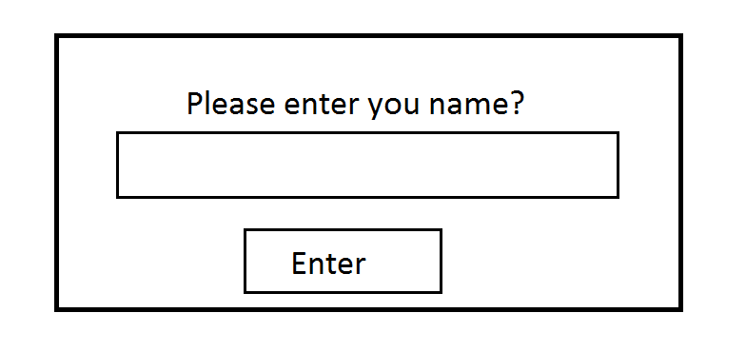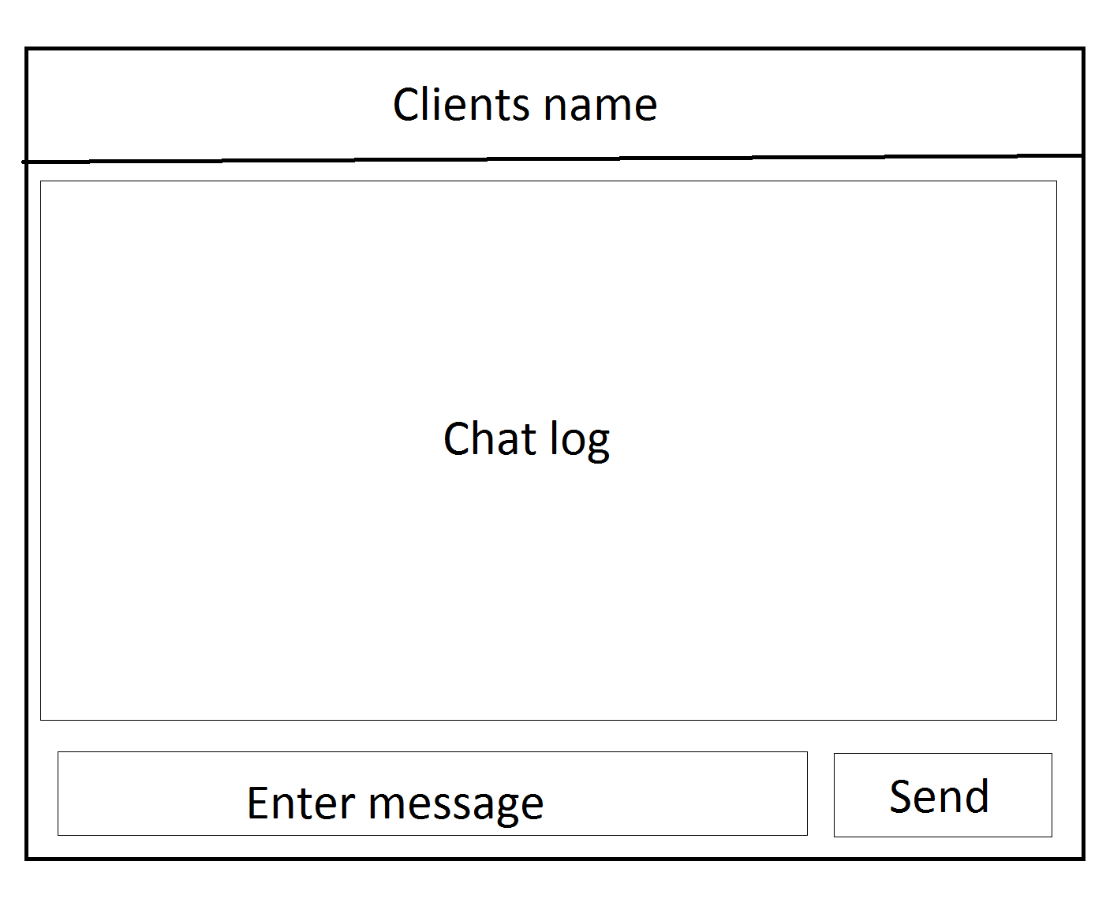

When the client is run I will make I popup appear asking the client for their name. I will then set the title of the gui to the users name. I will the store object in an arraylist on the server so that it can be referenced when necessary. I will put a textarea box in the centre of the gui which will show the users all the messages typed. The users name will be on the left and their message will be on the right. I will also put a textfield at the bottom and a send button so the users can post their own messages.

Class diagram

